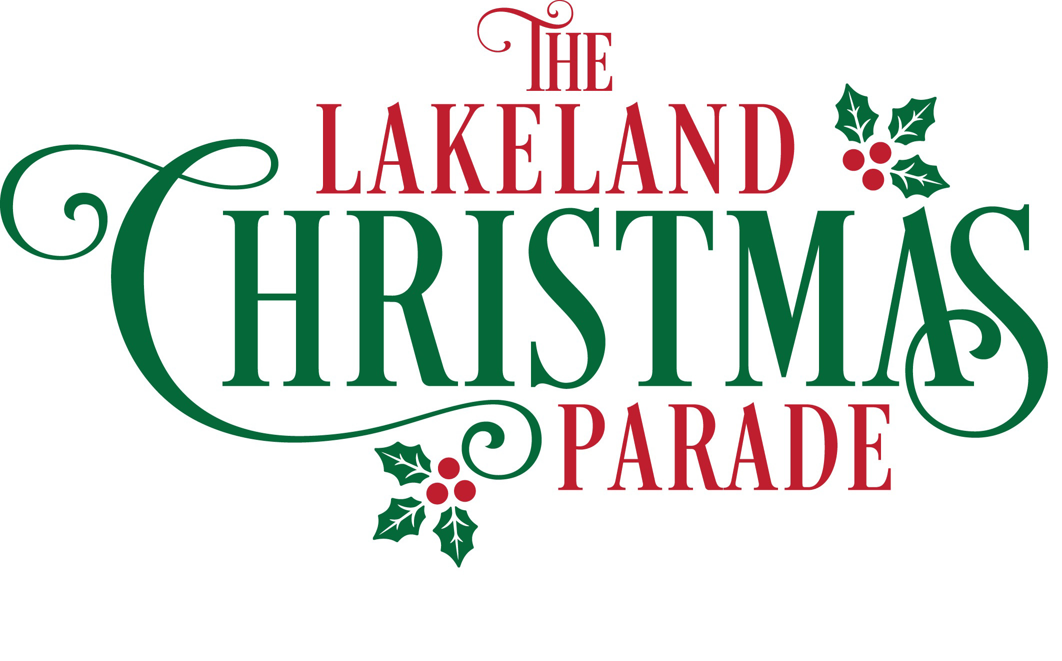

The Junior League of Greater Lakeland
with the City of Lakeland
Presents

“Christmas Past, Present, and Future”

Parade Date: December 1, 2022 at 7:00 PM
Float Origination Location: RP Funding Center, 701 W Lime Street, Lakeland FL 33815

OFFICIAL RULES
- Description of Parade Units:
- Regular Float: One that originates from sources other than a professional float company (i.e. ‘homemade’)
- Professional Float: One designed and constructed by a professional float company.
- Marching Band: Must be a performing group of moderate size. Drill teams may perform in conjunction with marching band units. Observance of 60 ft. spacing is requested to allow for proper camera coverage of units. Units must allow 2 to 3 ft. between unit and curb for police motorcycles.
- Cars: Only cars carrying public celebrities/officials will be accepted.
- Other: Any other type of unit not mentioned will only be allowed with the approval of the Parade Committee.

Participants Walking: There may be no more than 10 total walkers per unit. Please note that this limit includes all people and animals (other than horses). A maximum of 4 horses per unit are allowed. (Example: 5 dogs and 5 people would be permitted, and would count as 10 walkers)

Walking Units: Walking units will only be allowed with a float or decorated unit. A maximum of 10 walkers per unit (including chaperones and animals) are allowed. Anyone not on the float must be 12 years of age or older. No strollers or motorized scooters are allowed. Walkers shall be dressed to theme appropriately, including chaperones.

Animals: Animals will be accepted at the discretion of the Parade Committee. Units composed of live animals must be followed by a ‘pick-up’ person dressed in costume and must submit proof of liability insurance coverage.

- Decoration of Parade Units
- Santa is provided by the Parade Committee and MAY NOT appear on or with any unit. Any other Santa’s will be unable to participate in the event.
- Disney affiliated characters are provided by the Parade Committee and MAY NOT appear on or with any unit. Any individual portraying a Disney character will be unable to participate in the event. This determination shall be at the discretion of the Christmas Parade Chairs with JLGL.
- No flame or fire of any kind is allowed on or with any unit.
- Bubbles and snow are ONLY allowed if confined to float.
- No more than one golf cart will be permitted per unit. All golf carts that are included in the parade must also be decorated.
- All floats and wheeled units (excluding public official’s cars) are to be completely decorated with lights and weatherproof materials that can withstand transportation to and participation in the parade.
- The towing vehicle should be decorated and must be equipped with a tow bar, safety chains, and working break lights. All headlights on towing vehicles must be turned off or covered.
- The organization’s name shall be visible on the unit. However, the main purpose is to provide identification, not advertisement.
- The unit shall be no taller than 15 feet and no wider than 12 feet.
- Safety bars or some stable structure shall be provided for persons standing on the unit.
- Each application contains a unit description. Each participant has an obligation to update his or her application. Updates MUST be made by the night of the November meeting. We will not accept changes after this meeting. Meeting TBA.

- General Information
- Acceptance and determination of the order/position of units within the parade are the final decision made by the Parade Committee.
- Notification of your unit position will be provided at our mandatory participants meeting TBA.
- Any music played must be holiday music.
- No alcohol or smoking is allowed on or in any parade unit including floats, tow vehicles, cars, or on the premises of RP Funding Center or on the parade route. Anyone caught with alcohol or smoking will be dismissed immediately from participation in the event as well as the float in conjunction with same may be dismissed from participation and/or disqualified from scoring and/or participation in the parade the following year.
- All units participating in the parade are required to display a Junior League of Greater Lakeland placard sign on each side of their float. These will be given to units at time of check-in.
- Any person driving a motorized vehicle should have a valid driver’s license.
- Units may NOT STOP at any time during the parade. They should slow down for review at the judge’s stand.
- All parade participants should be picked up at the end of the parade route. Parents are encouraged to be in the south parking lot of the RP Funding Center waiting for their child’s arrival.
- Waiver of Liability forms will be required from each parade participant. Forms will be collected the night of the Parade from the parade float representative or may be turned in at the Participant’s Meeting. Do not mail waiver forms.
- Lost & Found will be located at the Registration area.
- No Unit/Participant may throw or hand our any item (i.e. candy, trinkets, beads, or pamphlets) to the crowd. Failure to comply will result in removal from the parade and confiscation of such items. The police are requested to enforce this rule.
- Only one (1) unit per organization accepted.
- Past Parade participation does not guarantee entry into this year’s parade.
- If your organization applied and was accepted into the 2022 parade, but your organization did not attend the parade, and did not provide any notice of the same, please note that you will not be considered for the 2023 parade but may be apply for acceptance again in 2024.

