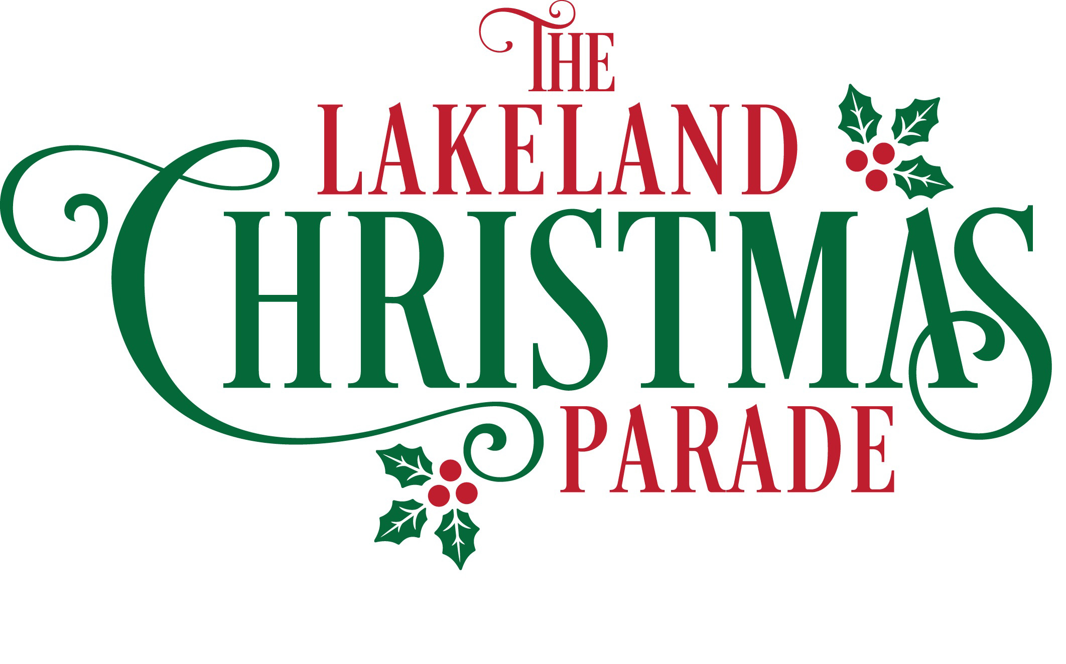
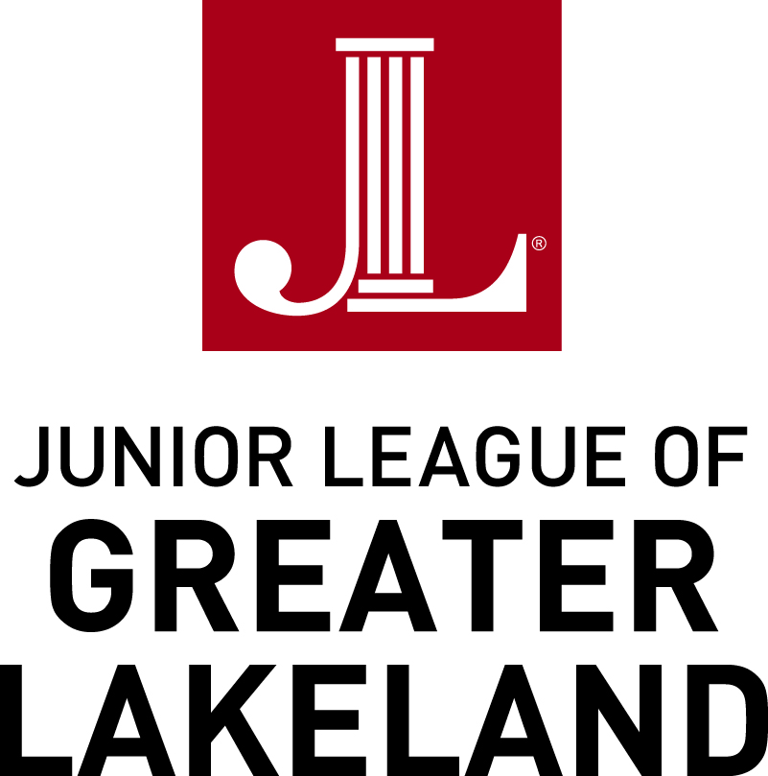

The Junior League of Greater Lakeland
with the City of Lakeland
presents
Parade Date: December 5, 2019 at 7:00 PM
Deadline for Applications: September 13, 2019

Dear Applicants,

The Junior League of Greater Lakeland and the City of Lakeland are proud to host the 39th annual Lakeland Christmas Parade. Thank you for your enthusiasm to participate in this important community holiday event.

The theme of this year’s parade is “The Joy of Giving.” This theme was inspired by the continuous generosity and love displayed within our community as touted by the nickname, “the Giving City.” We encourage each participant to showcase their creativity be decorating their float in such a way that highlights how our community gives to one another. How does your organization give to the community? What is your favorite aspect of our community? Decorations could highlight your art of dance, writing letters to soldiers, toy collections during the holidays, or your decorations could display aspects of our community that you love, such as our lakes, playgrounds and parks, swans, etc. In true holiday spirit, we ask that you enhance the display on your float with festive cheer; it is Christmas after all!

Please review the information contained within carefully as all floats are accepted for participation based on compliance with the provided rules, completion of the application in full, and on the basis of the unit’s quality and contribution to the parade. Please remember that any music played must be holiday music. Also, no alcohol is allowed on or in any parade unit including floats, tow vehicles, cars, or on the premises of RP Funding Center or on the parade route.

Awards will be presented to outstanding participants at the Lakeland City Commission meeting in December. We look forward to partnering with you to provide our community with another wonderful Christmas Parade.

Yours in service,

Hannah George & Chelsea Mullings Callie Miller
Christmas Parade Committee Co-Chairs President
Junior League of Greater Lakeland Junior League of Greater Lakeland
The Junior League of Greater Lakeland is an organization of women committed to promoting voluntarism, developing the potential of women and improving the community through the effective action and leadership of trained volunteers. The Junior League is exclusively educational and charitable.
Instructions

Step 1: Download and Complete APPLICATION and MEDIA FORM with script.
Note: Please type your responses and save as a Word Document.

- APPLICATION:
- Applications must be completed in FULL and submitted prior to the deadline. The application includes two parts:
    - The General Application Information (page 3)
    - Choose One to Complete:
        - Regular Float (Not Professional, page 4)
        - Professional Float (page 5)
        - Marching Band (page 6)
        - Car (Reserved for Public Officials Only, page 6)
        - Other (Describe, page 6)
  - If a submitted application is not completed in full and/or is submitted after the deadline, it will not be considered. All applications will be given equal consideration. Please be sure to review the official rules.
  - Submission of a timely and complete application and/or prior parade participation does NOT guarantee your spot in the parade.

- MEDIA FORM WITH SCRIPT:
Complete the requested script on the Media Form, page 7. The script must be provided at the time your application is submitted. Please include in your script which storybook inspired your float. Applications will not be accepted without a script.

Step 2: Email Submission.
Email the completed Application and Script as a Word Document to ChristmasParade@JLGL.org.

Step 3: Mail $35 Payment & Signed Application.
A $35 Check of Money Order made out to the City of Lakeland must be mailed with a copy of your printed and signed application. Please mail both items to:

Junior League of Greater Lakeland
PO Box 8797, Lakeland, FL 33806-8979

Please note the following:
- Public Officials and Marching Bands are exempt from the application fee. However, they must complete the Application and Media Form with Script.
- All checks will be cashed upon receipt. Cashing of a check is not an indication of acceptance in the parade. However, if your application is not accepted, you will receive a refund.

You will receive an email confirming your acceptance or a mailed letter to notify of your rejection by October 11, 2019.

- APPLICATION
Submission Deadline: September 13, 2019
General Applicant Information
Organization Name: Click here to enter text.
Organization’s Mailing Address: Click here to enter text.
Organization’s Phone Number: Click here to enter text.
Are You a New Applicant? (YES or NO) Choose an item.
How many years has your organization participated in the parade? Click here to enter text.
Contact Name: Click here to enter text.
Contact Email: (for acceptance email) Click here to enter text.
Cell Phone Number: (to be used on parade day) Click here to enter text.

Type of Parade Unit Applying: (Mark one with an ‘X’ and complete corresponding section of the application)
☐A. Regular Float (NOT PROFESSIONAL, page 4)
☐B. Professional Float (page 5)
☐C. Marching Band (page 6)
☐D. Car (Reserved for Public Officials only, page 6)
☐E. Other (Describe, page 6)

ALL APPLICANTS, please read official rules and descriptions of unit types and decorating guidelines.
If you have any questions or concerns, please email ChristmasParade@JLGL.org.

The applicant agrees to indemnify and save harmless the City of Lakeland, the Junior League of Greater Lakeland, Florida, Inc., their agents and employees from and against all claims, demands, losses and damages of any kind or description resulting from injury to persons, or death or property damages arising from applicant participation in the Junior League / City of Lakeland Christmas Parade. The applicant agrees that no alcohol will be allowed in or on any parade unit or on RP Funding property or the parade route.
(PLEASE SIGN BELOW ON PRINTED COPY ONLY)
__________________________________________________________________ ____________________________________________________
Applicant’s Signature Date

- Regular Float
(Not Professional)

Please refer to Official Rules and Information as your plan your float.

- Please describe your theme: (Floats following the theme, “The Joy of Giving,” will be given preference)
Click here to enter text:

- Dimensions:
Float: Height Click here to enter text. & Length Click here to enter text.
Towing Vehicle: Height Click here to enter text.& Length Click here to enter text.
- Visible Construction: (What will be on your float?)
Click here to enter text.
- Required Lighting:
Click here to enter text.
- Music: (Please indicate whether the music will be live or recorded; also, all music must be holiday music)
Click here to enter text.

- Number of Participants on Float: Click here to enter text.
- Number of Walkers: (See Official Rules for Limits) Click here to enter text.
- Towing Vehicle: (mark only one with an ‘X’)
☐ Car ☐ Truck ☐ Jeep ☐Other (please describe) Click here to enter text.
- Animals: (See Official Rules for Limits)
Click here to enter text.
B. Professional Float
Float Company Name: Click here to enter text.
Float Company Mailing Address: Click here to enter text.
Float Company Phone Number: Click here to enter text.
For your convenience, we have listed the following float company that organizations have used in the past:
Festive Floats of Florida
Contact: Chick or Bruce Adams
Phone: (813) 879-2878
Email: FestiveFloats@EarthLink.Net
2102 Orient Road, Tampa, Florida 33619
www.FestiveFloats.com (picture gallery available)

Please complete in detail the following section as it pertains to the unit for which you are applying.
Please refer to Official Rules and Information as your plan your float.

- Please describe your theme: (Floats following the theme, “The Joy of Giving,” will be given preference)
Click here to enter text.
- Visible Construction: (What will be on your float?)
Click here to enter text.
- Music: (Please indicate whether the music will be live or recorded; also, all music must be holiday music)
Click here to enter text.

- Number of Participants on Float: Click here to enter text.
- Number of Walkers: (See Official Rules for Limits) Click here to enter text.
- Animals: (See Official Rules for Limits)
Click here to enter text.
Marching Band, Public Officials in Cars, & Other
C. Marching Band
Name of Band: Click here to enter text.
Point of Contact: Click here to enter text.
Approximate number of participants marching: Click here to enter text.
Approximate number of other participants: Click here to enter text.
Describe: Click here to enter text.

D. Public Officials in Cars
(reserved for public officials only)
Make of Car: Click here to enter text.
Model of Car: Click here to enter text.
Organization / Person Being Represented: Click here to enter text.

E. Other
Describe: Click here to enter text.

- MEDIA FORM WITH SCRIPT

It is mandatory that ALL participants provide a 30-second written script describing their entry in the 38th annual Lakeland Christmas Parade. The script must be submitted with your application.
- Free 30-second Commercial: The script that you write is your free 30-second commercial about your organization or group to be announced to the entire Polk County viewing audience. The Parade will be broadcast throughout the month of December so be sure your script tells a good story!
- Key Talking Points: The co-host announcers will read as much of your script as time allows. Thus, your opening 3-4 sentences need to be clear and entertaining for the viewing audience.
Please include in the first four sentences:
  - Name of your Organization
  - Storybook that inspired your theme / other theme for your float
  - What you organization / group / business provides
  - General statement of who is on your float (i.e. the school’s accelerated readers)
If you provide names of people on your float, please also provide the phonetic spelling of the names (i.e. Pongpathed – pronounced: Pomp A Thed) to ensure names are correctly announced.
  - Finish your script by including any other pertinent details.
- Example Scripts:
  - Run, Run Rudolph! It’s time to Round ‘Em up! Here comes A Heart for Others with their float inspired by the Annual Rudolph Round-Up Toy Drive. Each year A Heart for Others hosts an annual toy drive which to provide amazing holiday memories for children in the local area. This is just one of the many ways A Heart for Others gives back to our community and serves children and families that have been subject to abuse or neglect. A Heart for Others mission is to “Enhance safety, permanency, and well-being for all children throughout the State of Florida.”
  - The doctor is in! Here come the amazing doctors, nurses, and staff with the Lakeland Health Clinic skiing on their favorite Lakeland lake, Lake Hollingsworth. Look at how their skis are beautiful lit with twinkling Christmas lights! The Lakeland Health Clinic provides a state-of-the-art medical facility and high quality healthcare to the residents of Polk County and the team there is especially thankful for the beautiful walking paths and outdoor activities available to keep our community healthy. They want to encourage you to be active in our community for at least 30 minutes a day!
- Your Script: (please type your script in the section below)
Click here to enter text.

