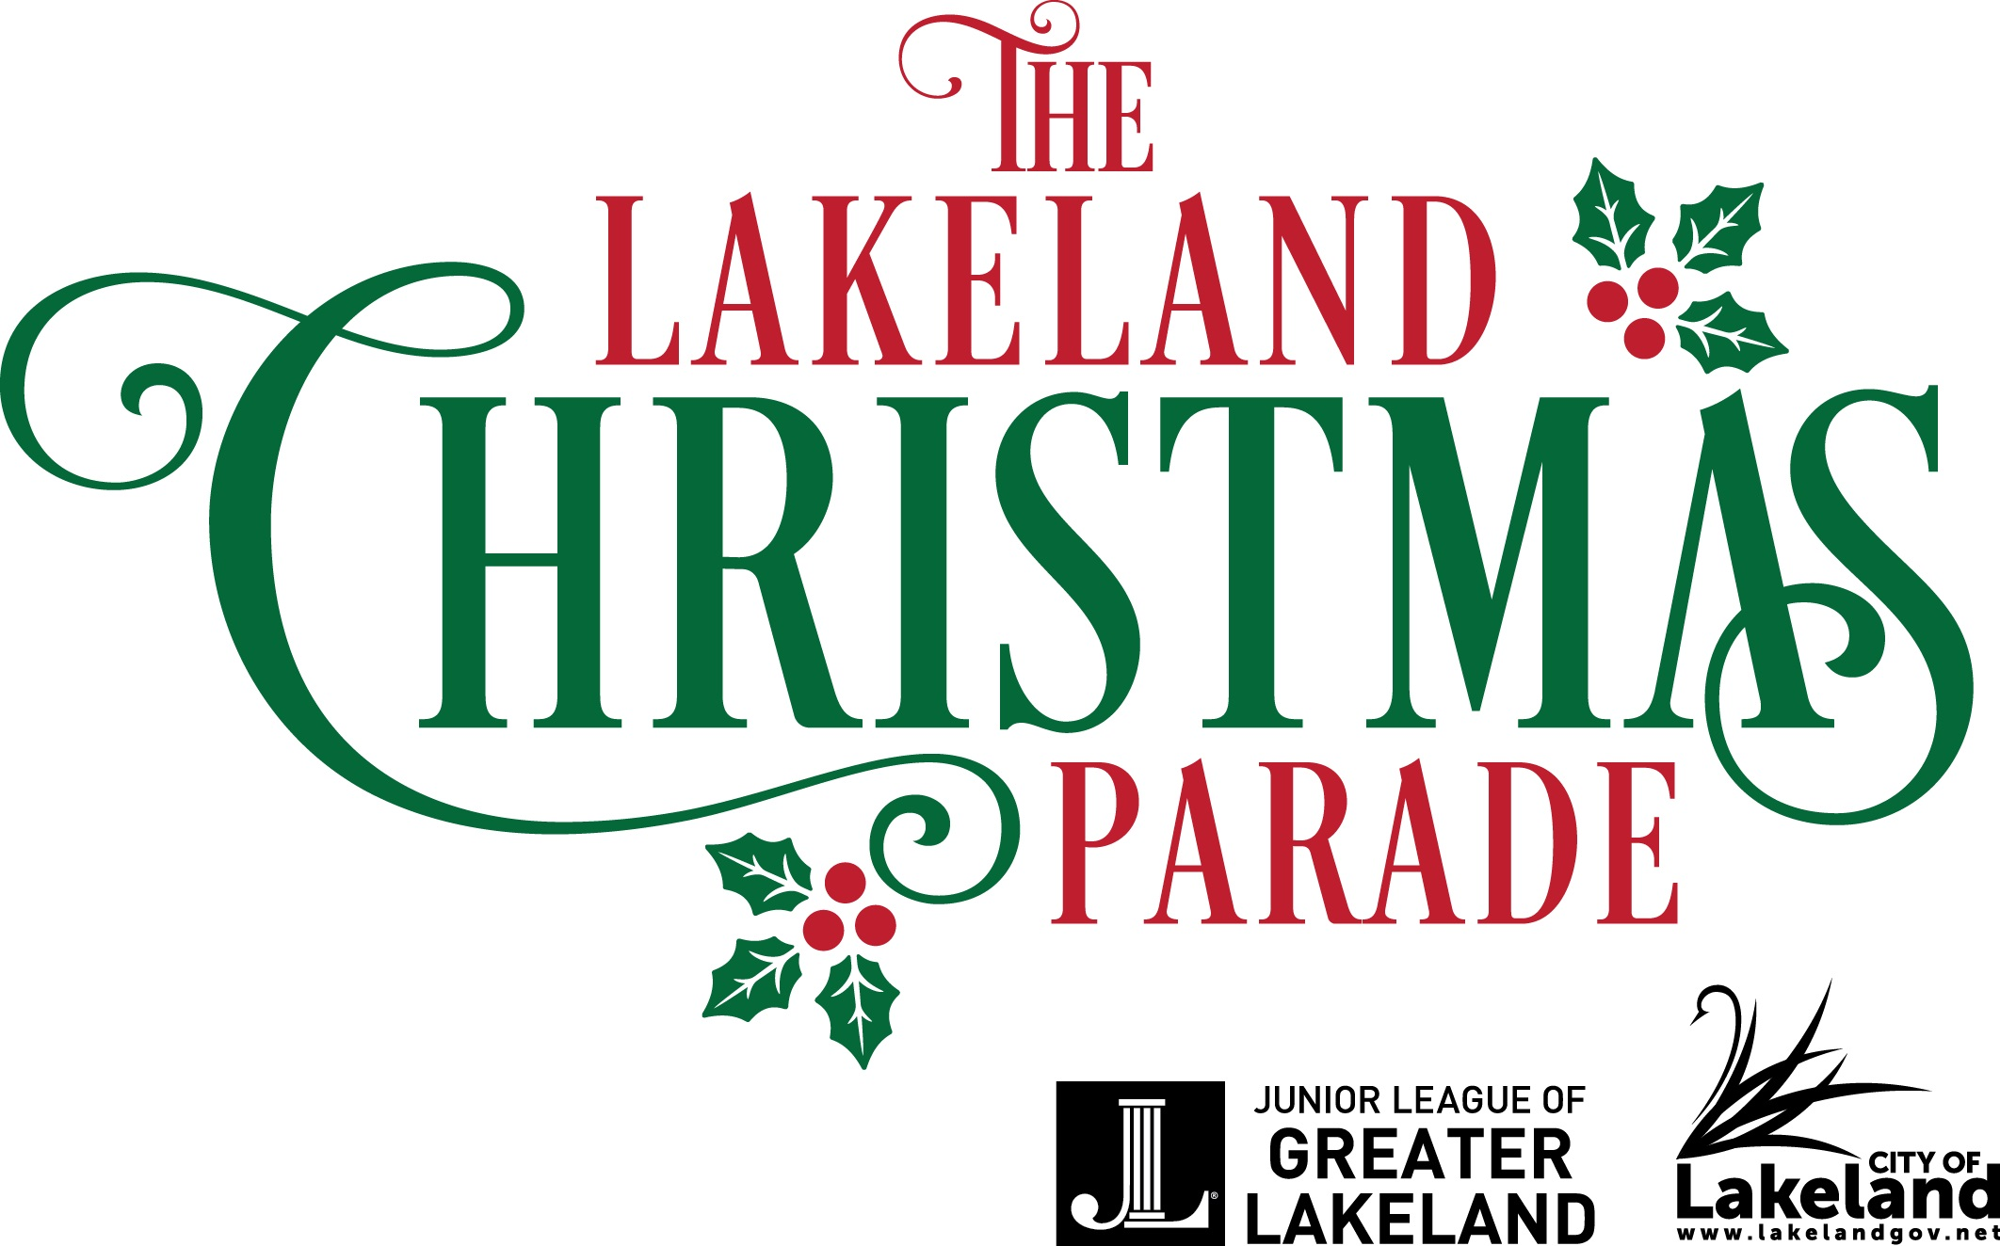

The Junior League of Greater Lakeland
with the City of Lakeland
Presents
“Christmas Past, Present, and Future”
Parade Date: December 1, 2022 at 7:00 PM
Deadline for Applications: September 16, 2022
Dear Applicants,

The Junior League of Greater Lakeland and the City of Lakeland are proud to host the 41st Annual Lakeland Christmas Parade. Thank you for your enthusiasm to participate in this important community holiday event.

The theme of this year’s parade is “Christmas Past, Present, and Future”. This theme was inspired by our love for the holiday season, and our community over our 90 years of service. Christmas Past represents our fond memories of holiday traditions with those we love and cherish. Christmas Present portrays the generosity and good will that we have for one another and our beautiful community. And Christmas Future paints a picture of what is yet to come - and all the possibilities our future holds.

We encourage each parade participant to showcase their creativity by decorating their float in a way that exudes a Christmas Past, Present, or Future. We are looking to see floats showcasing holiday cheer of a favorite pastime, a new tradition, or what they would like to see in the future for this time of year, as well as embrace the holiday spirit through festive décor, bright lights (of all sizes), dramatic displays of colors, music, and more. “And Scrooge said: ‘I will honour Christmas in my heart and try to keep it all the year. I will live in the Past, the Present, and the Future. The Spirits of all Three shall strive within me. I will not shut out the lessons that they teach.’" - Ebenezer Scrooge, A Christmas Carol

Please review the information contained within carefully as all floats are accepted for participation based on the compliance with the provided rules, completion of the application in full, and based on the unit’s quality and contribution to the parade. Awards will be presented to outstanding participants at the Lakeland City Commission meeting in December.

We look forward to providing our community with another wonderful Christmas Parade. Thank you for your participation.

Yours truly,
Nicole Minott & Vicki Russell Maggie Briggs
Christmas Parade Co - Chairs President
Junior League of Greater Lakeland Junior League of Greater Lakeland

The Junior League of Greater Lakeland is an organization of women committed to promoting voluntarism, developing the potential of women and improving the community through the effective action and leadership of trained volunteers. The Junior League is exclusively educational and charitable.
Instructions

Step 1: Download and Complete APPLICATION and MEDIA FORM with script.

- APPLICATION:
- Applications must be completed in FULL and submitted prior to the deadline (September 16, 2022). If a submitted application is not completed in full and/or is submitted after the deadline, it will not be considered. All applications will be given equal consideration. Please be sure to review the official rules.
- Submission of a timely application, a complete application and/or prior parade participation does NOT guarantee your spot in the parade.

- MEDIA FORM WITH SCRIPT:
Please be sure the Media Form and Script are completed in FULL, including a script at the time of submission. Applications will not be accepted without a script.

Step 2: Application Submission.
Email the Application and Media Form with your Script as a Word Document to Parade@JLGL.org.

Step 3: Payment & Signed Application. (Please select one (1) option for payment)
Mail a Check or Money Order made out to the City of Lakeland in the amount of $35, along with a copy of your PRINTED and SIGNED application to JLGL, PO Box 8797, Lakeland, FL 33806-8979. Please note that any applications which do not meet the requirements for participation will have their entry fees refunded to them at the earliest convenience.

Please note the following:
- Public Officials and Marching Bands are exempt from the application fee. However, they must complete the Application and Media Form with Script.
- All checks will be cashed upon receipt. Cashing of a check is not an indication of acceptance in the parade. However, if your application is not accepted, you will receive a refund.

You will receive an email confirming your acceptance or a mailed letter to notify of your rejection by October 10, 2022.

- APPLICATION
Submission Deadline: September 16, 2022

General Applicant Information
Organization Name: ____________________________________________________________________________________________________
Organization’s Mailing Address: ______________________________________________________________________________________
Organization’s Phone Number: _______________________________________________________________________________________

Are You a New Applicant? (circle) YES or NO
How many years has your organization participated in the parade? _________ years

Contact Name: __________________________________________________________________________________________________________
Contact Email: (for acceptance email) __________________________________________________________________________________
Cell Phone Number: (to be used on parade day) ________________________________________________________________________

Type of Parade Unit Applying: (select one and complete corresponding section of the application)
- A. Regular Float (NOT PROFESSIONAL, page 4)
- B. Professional Float (page 5)
- C. Marching Band (page 6)
- D. Car (Reserved for Public Officials only, page 6)
- E. Other (Describe, page 6)

ALL APPLICANTS, please read official rules and descriptions of unit types and decorating guidelines.
If you have any questions or concerns, please email Parade@JLGL.org.

The applicant agrees to indemnify and save harmless the City of Lakeland, the Junior League of Greater Lakeland, Florida, Inc., their agents, and employees from and against all claims, demands, losses and damages of any kind or description resulting from injury to persons, or death or property damages arising from applicant participation in the Junior League / City of Lakeland Christmas Parade.
(PLEASE SIGN BELOW ON PRINTED COPY ONLY)

__________________________________________________________________ ____________________________________________________
Applicant’s Signature Date

- Regular Float Application
(Not Professional)

Please refer to Official Rules and Information as your plan your float.

- Please describe your theme: (Floats following the “Christmas Past, Present, and Future”’ theme will be given preference)
_______________________________________________________________________________________________________________________
_______________________________________________________________________________________________________________________
_______________________________________________________________________________________________________________________
_______________________________________________________________________________________________________________________
- Dimensions:
Float: Height ________________ & Length ________________
Towing Vehicle: Height ________________ & Length ________________
- Visible Construction: (What will be on your float?)
_______________________________________________________________________________________________________________________
_______________________________________________________________________________________________________________________
_______________________________________________________________________________________________________________________
- Required Lighting:
_______________________________________________________________________________________________________________________
_______________________________________________________________________________________________________________________
_______________________________________________________________________________________________________________________
- Music: (Please indicate whether the music will be live or recorded.)
_______________________________________________________________________________________________________________________

- Number of Participants on Float: ________________
- Number of Walkers: (See Official Rules for Limits) ________________
- Towing Vehicle: (mark only one with an X)
_______________ Car _______________ Truck _______________ Jeep
_______________ Other (please describe) ___________________________________________________________________________
- Animals: (See Official Rules for Limits)
_______________________________________________________________________________________________________________________

B. Professional Float Application
Float Company Name: _________________________________________________________________________________________________
Float Company Mailing Address: _____________________________________________________________________________________
Float Company Phone Number: _______________________________________________________________________________________
For your convenience, we have listed the following float company that organizations have used in the past:
Festive Floats of Florida
Contact: Tonya or John Roberts
Phone: (813) 879-2878
Email: FestiveFloats@EarthLink.Net
2102 Orient Road, Tampa, Florida 33619
www.FestiveFloats.com (picture gallery available)

Please complete in detail the following section as it pertains to the unit for which you are applying.
Please refer to Official Rules and Information as your plan your float.

- Please describe your theme: (Floats following the “Christmas Past, Present, and Future” theme will be given preference)
_______________________________________________________________________________________________________________________
_______________________________________________________________________________________________________________________
_______________________________________________________________________________________________________________________
_______________________________________________________________________________________________________________________
- Visible Construction: (What will be on your float?)
_______________________________________________________________________________________________________________________
_______________________________________________________________________________________________________________________
_______________________________________________________________________________________________________________________
- Music: (Please indicate whether the music will be live or recorded.)
_______________________________________________________________________________________________________________________

- Number of Participants on Float: ________________
- Number of Walkers: (See Official Rules for Limits) ________________
- Animals: (See Official Rules for Limits)
_______________________________________________________________________________________________________________________

Marching Band, Public Officials in Cars, & Other
C. Marching Band
Name of Band:
Point of Contact:
Approximate number of participants marching:
Approximate number of other participants:
Describe: ________________________________________________________________________________________________________________
___________________________________________________________________________________________________________________________
___________________________________________________________________________________________________________________________

D. Public Officials in Cars
(reserved for public officials only)
Make of Car:
Model of Car:
Organization / Person Being Represented:

E. Other
Describe: ________________________________________________________________________________________________________________
___________________________________________________________________________________________________________________________
___________________________________________________________________________________________________________________________

- MEDIA FORM WITH SCRIPT
- Participant’s Mandatory Unit Description Script: It is mandatory that ALL participants provide a 30-second written script describing their entry in the 41st annual Lakeland Christmas Parade.
- Submission Deadline: The script must be submitted with your application by September 16, 2022..
- Free 30-second Commercial: The script that you write is your free 30-second commercial about your organization or group to be announced to the entire Polk County viewing audience. The Parade will be broadcast throughout the month of December so be sure your script tells a good story!
- Key Talking Points: The co-host announcers will read as much of your script as time allows. Thus, your opening 3-4 sentences need to be clear and entertaining for the viewing audience.
Please include in the first four sentences:
  - Name of your Organization
  - Theme for your float? How does your organization plan to make the future Season of Joy?
  - What your organization / group / business provides
  - General statement of who is on your float (i.e. the school’s accelerated readers)
If you provide names of people on your float, please also provide the phonetic spelling of the names (i.e. Pongpathed – pronounced: Pomp A Thed) to ensure names are correctly announced.
  - Finish your script by including any other pertinent details.
- Example Script:

  - The doctor is in! Here come the amazing doctors, nurses, and staff with the Lakeland Health Clinic skiing on their favorite Lakeland lake, Lake Hollingsworth. Look at how their ski’s are beautiful lit with twinkling Christmas lights! Over 1,000 lights were used to light up their amazing float this evening. The Lakeland Health Clinic provides a state-of-the-art medical facility and high-quality healthcare to the residents of Polk County and the team there is especially thankful for the beautiful walking paths and outdoor activities available to keep our community healthy. They want to encourage you to be active in our community for at least 30 minutes a day!

- Your 30 Second Script: (please type your script in the box below)
[SCRIPT]

